Handout Softwareengineering

Teamname: LogicGame

Teammembers:

|  |  |
| --- | --- |
| Tim Farahani | [Tim.farahani@gmail.com](mailto:Tim.farahani@gmail.com) |
| Maximilian Maier | Maier-max@gmx.de |
| Marcel Sommer | Marcel.sommer1994@gmx.de |

Time Sheet:

Tim:

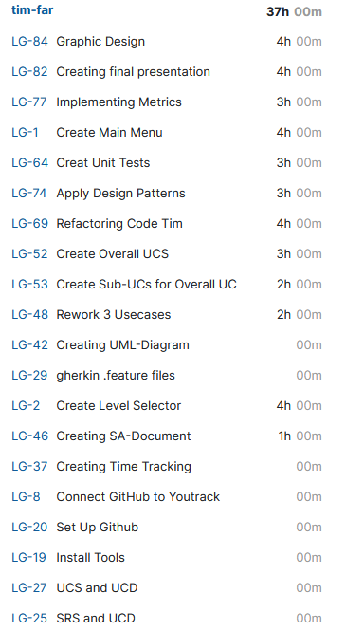

Marcel:

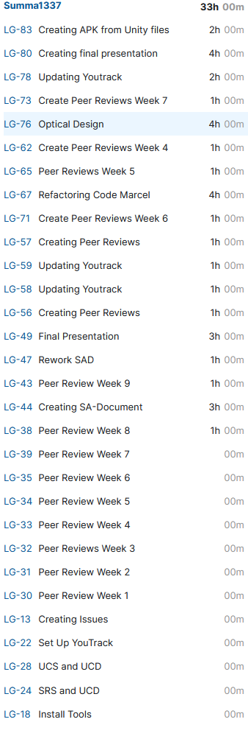

Max:

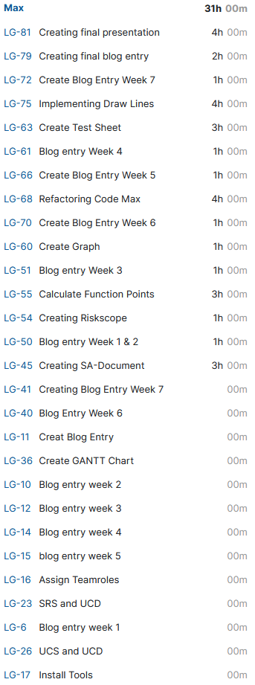

Overall UCD

